Nama : Sofanji

NIM : 18090098

Kelas : 5C

PRAKTIKUM 2

1. Source Code

latihan1-> application/controller

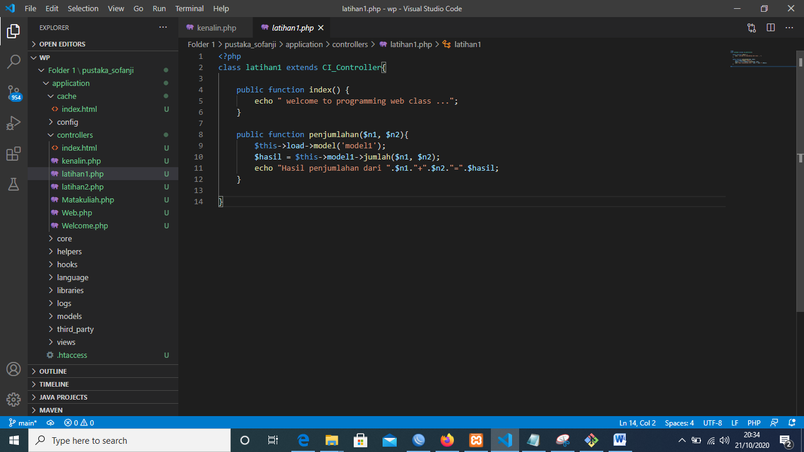

latihan2 -> application/controller

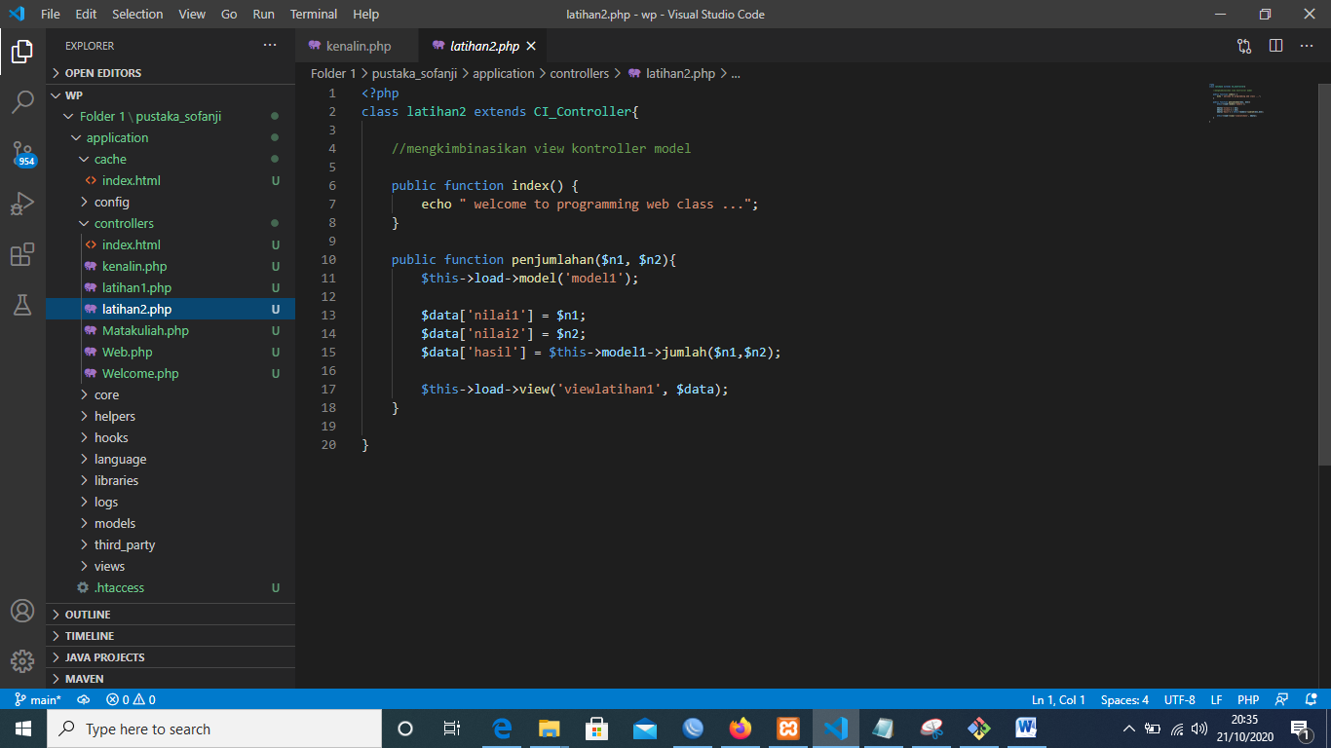

model1 -> application/model

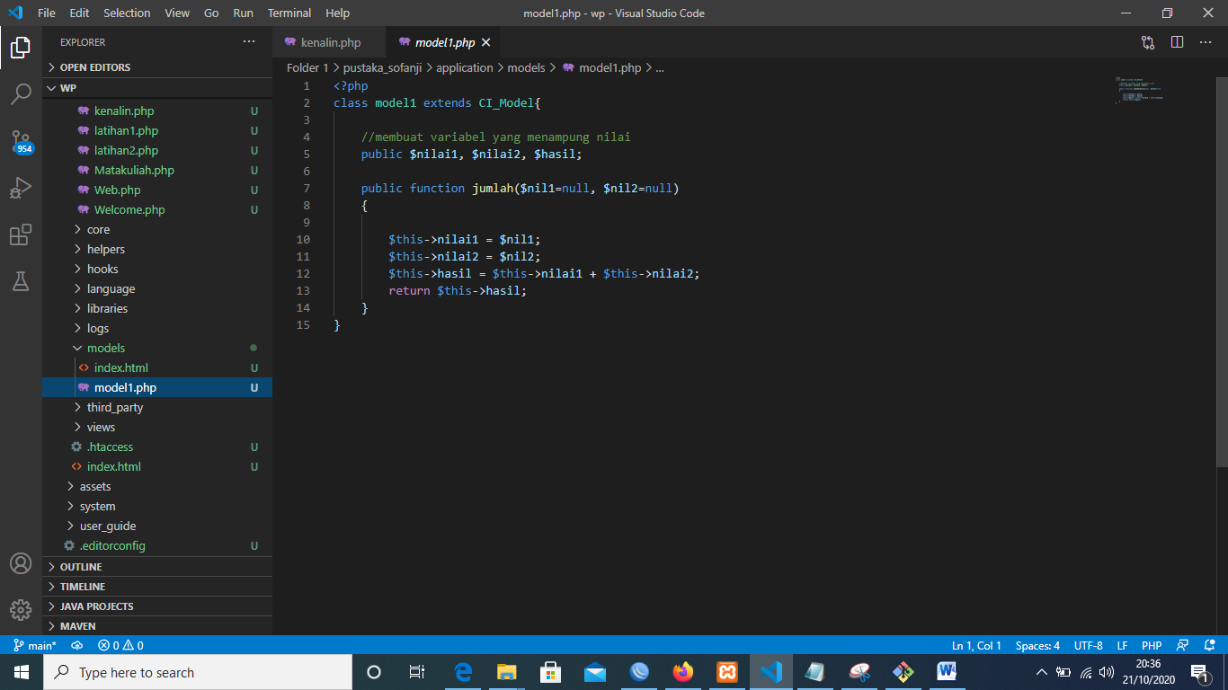

viewlatihan1.php->application/view

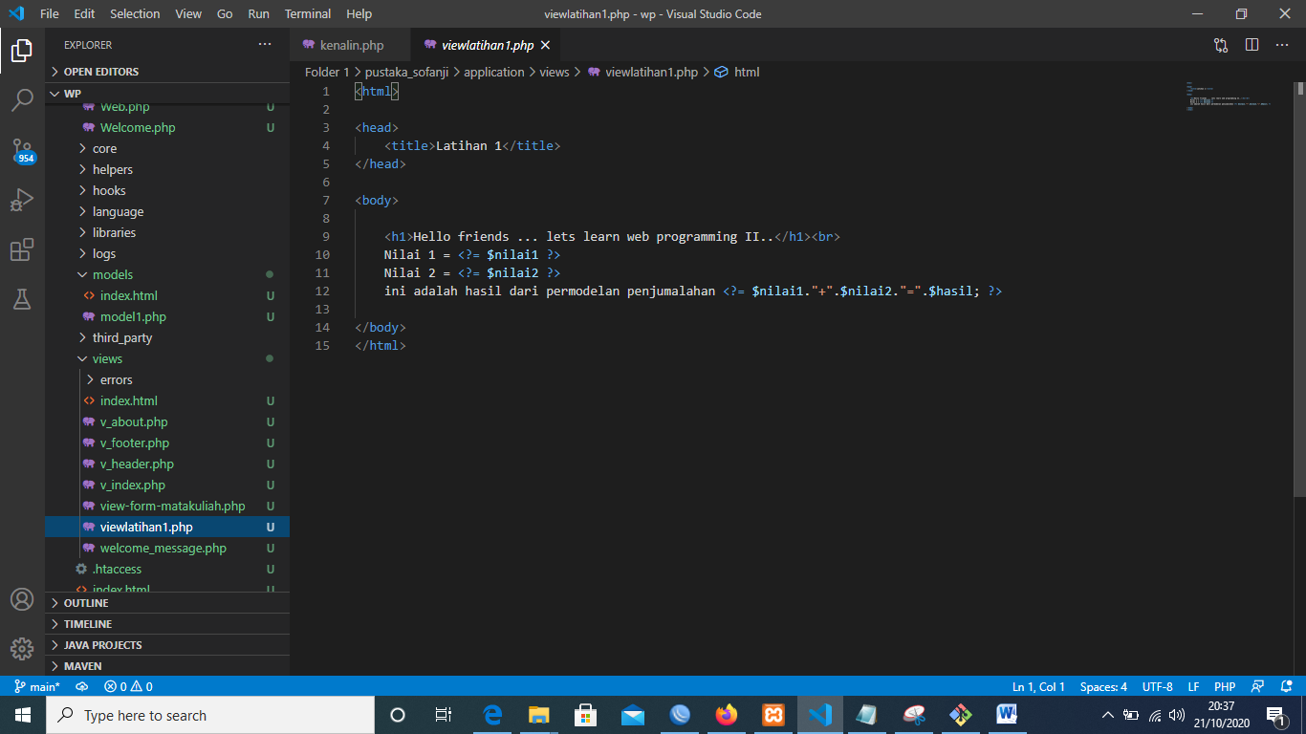

1. URL

<http://localhost/pustaka_sofanji/index.php/latihan2>

<http://localhost/pustaka_sofanji/index.php/latihan2/penjumlahan/1/6>

<http://localhost/pustaka_sofanji/index.php/latihan1/penjumlahan/4/5>

1. Capture Hasil

**Hasil run latihan 2**

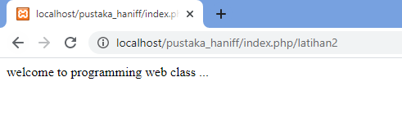

**Hasil run penjumlahan**

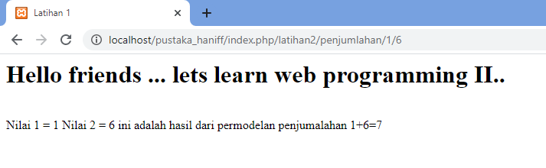

**Hasil run latihan 1**

